**Experiment No:1**

**Title: Basic Linux Command**

**Problem Statement: Execution of basic Linux commands**

**Solution:**

**General Purpose Commands:**

1. **date: Displays the current date and time of the system.**

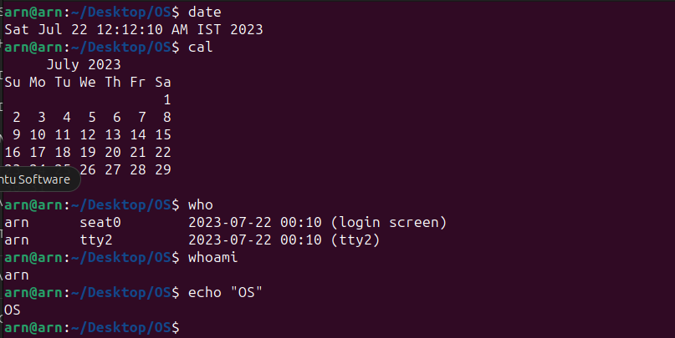

1. **cal: Displays a calendar for the current month.**



1. **who: Lists the users who are currently logged on to the system.**



1. **whoami: Reports the username of the currently logged-in user.**



1. **echo: Echoes a string (or list of arguments) to the terminal, displaying it on the**

**screen.** 

1. **bc: A command-line calculator that allows you to perform mathematical operations.**

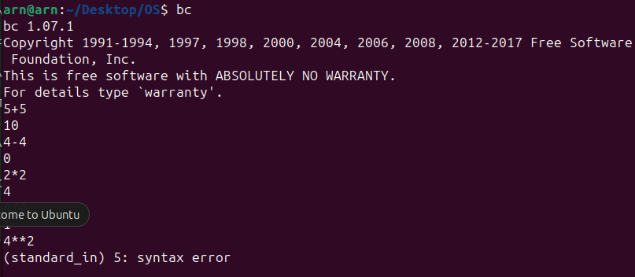

1. **clear: Clears the terminal screen, providing a clean slate.**

**Before:**

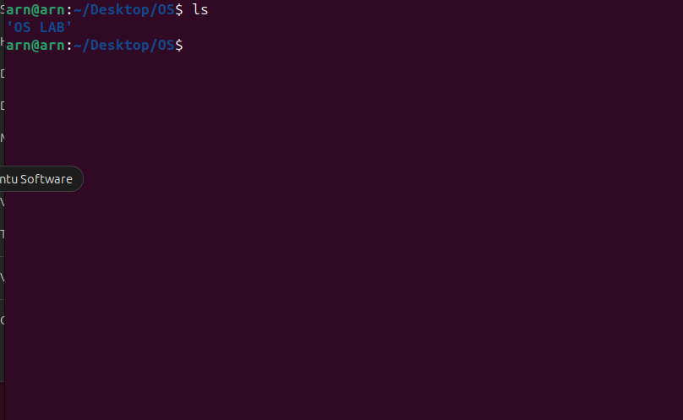

**After:**

1. **alias: Used to create custom shortcuts (aliases) for commands. In the given examples:**

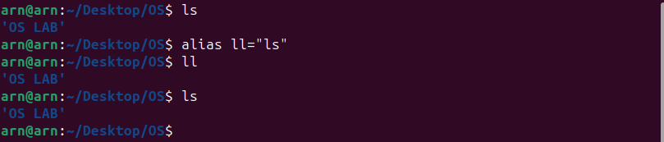

* + **alias erase=rm: Creates an alias 'erase' for the 'rm' command, so 'erase file.txt' will remove 'file.txt'.**
  + **alias grep="grep -i": Creates an alias 'grep' that includes the '-i' option to perform case-insensitive searches by default.**
  + **alias cp="cp -i": Creates an alias 'cp' that includes the '-i' option to prompt for confirmation before overwriting files.**

1. **man <cmd name>: Displays the manual page for the specified command, providing information on its usage and options.**



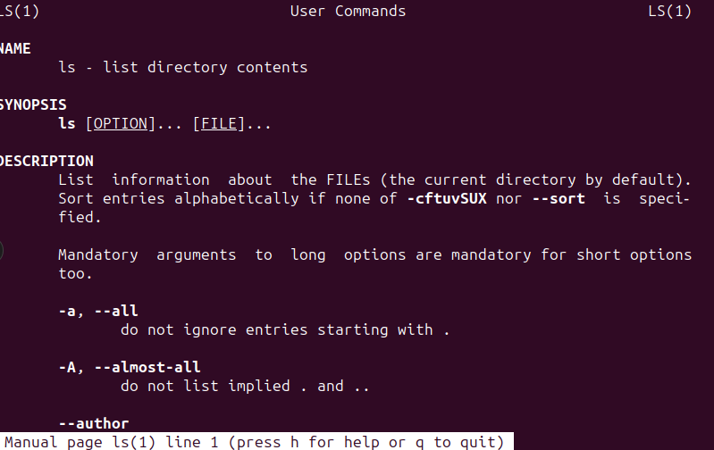

1. **passwd: Allows the currently logged-in user to change their password.**

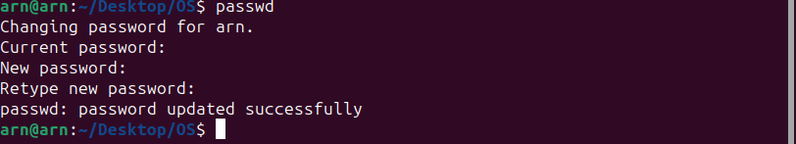

1. **exit: Terminates the current terminal session and logs the user out.**

**File & Directory Related Commands:**

1. **cp <fromfile> <tofile>: Copies the content of the <fromfile> to the <tofile>.**

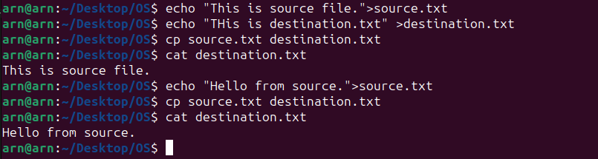

1. **mv <fromfile> <tofile>: Moves or renames the <fromfile> to the <tofile>. If the <tofile> already exists, the command will overwrite it.**

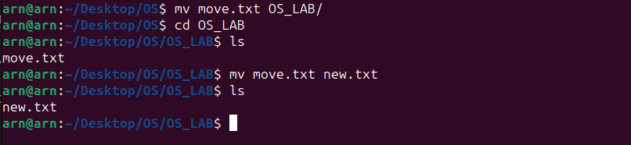

1. **rm <file>: Removes or deletes the file named <file>.**



1. **mkdir <newdir>: Creates a new directory with the name <newdir>.**

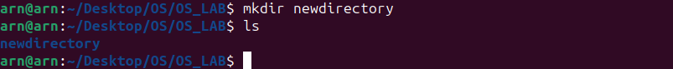

1. **rmdir <dir>: Removes an empty directory named <dir>. The directory must be empty for this command to work.**

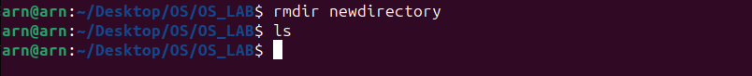

1. **cd <dir>: Changes the current working directory to <dir>, allowing you to navigate the file system.**

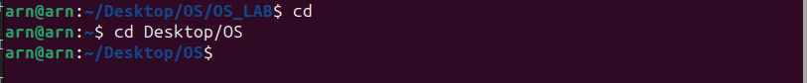

1. **pwd: Prints (displays) the working directory, showing the path of the current directory.**



1. **cat > <file>: Creates a new file named <file> and allows you to enter content. Press Ctrl + D to save the content and exit.**



1. **cat >> <file>: Appends content to an existing file named <file>.**

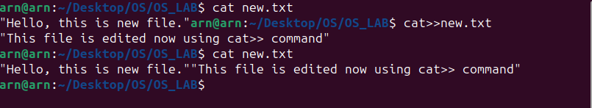

1. **cat <file>: Displays the contents of the existing file named <file> on the terminal.**



1. **more <file>: Pages through the contents of the file named <file. It allows you to read large files one screen at a time.**

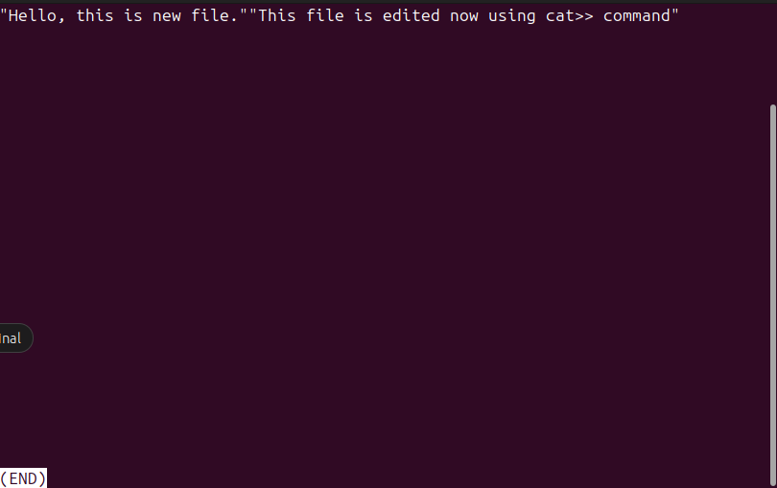

1. **file <file>: Checks and displays the type of <file> (e.g., text, binary, etc.).**

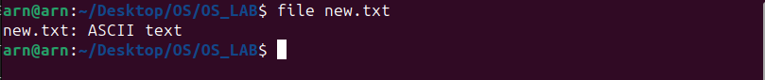

1. **wc <file>: Counts the number of lines, words, and characters in the file named <file>.**



1. **cmp <file1> <file2>: Compares two files, showing the first offset where they differ.**

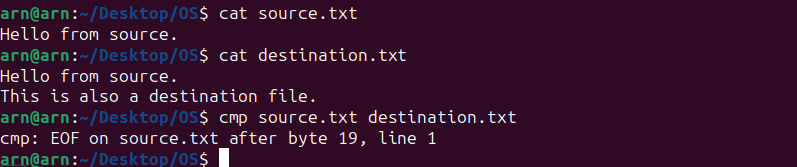

1. **comm <file1> <file2>: Displays lines that are common, unique, or different between two sorted files.**

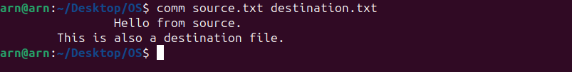

1. **diff <file1> <file2>: Compares two text files and displays the differences between them.**

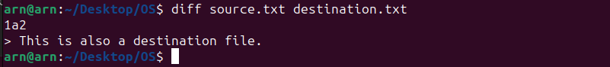

1. **gzip <file>: Compresses the file named <file> and adds a '.gz' extension to the compressed file.**

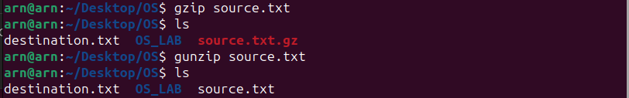

1. **gunzip <file>: Decompresses a gzipped file named <file>.**



1. **ls: Lists the files and directories in the current working directory.**



1. **ls <dir>: Lists all files and directories in the given directory <dir>.**



1. **ln <fromfile> <tofile>: Creates a symbolic link (shortcut) to the <fromfile> with the name <tofile>. The link behaves as if it were the original file, and changes in one affect the other.**



**Conclusion: We have studied basic Linux command**